

Project Report (Draft)

Prepared for

Dr. Raafat Saadé

Prepared by

Hao Yin #5043328

skyincookoo@gmail.com

Course

DESC 385

Decision Support System

Date
March 18, 2005
Table of Content
(Under work)

Project Report (Draft) 1
Prepared for 1
Dr. Raafat Saadé 1
Prepared by 1
Hao Yin #5043328 1
skyincookoo@gmail.com 1
Course 1
DESC 385 1
Decision Support System 1
Date 1
In order to find the Optimal Risky Portfolio, we need several steps of calculation. 6
After performing optimization, I got the result. 8
F(stock) = {if optimized weight > 0 : result = live; else result = die} 11
F(stock) = {α₁* f₁ + α₂* f₂ + α₃*f₃ + α₄*f₄ >β : result = live; else result = die} 11
System Limitation 15
J. C. Fancis and R. Ibbotson: “Investments: A Global Perspective,” 2002, Ch. 14. 16
Sengupta, Chandan: “Financial modeling: using Excel and VBA,” 2004. Ch. 16
C. Gustav Lundberg and A. C. Barna: “Modeling Commodity Trading Expertise,” 1992 16
Thomas S. Y. Ho and Sang B. L.: “The Oxford Guide to Financial Modeling,” 2004, Ch. 2 16

- Introduction

basic

- Objective
Basically, there are two key decisions to make for every stock investor: what to buy and how many to buy. However, many of them made such decisions by intuition, more or less. Powered by Markowitz Portfolio Theory, this system is designed to optimize investor’s current or planed stock portfolio so as to address above two questions.

- Data

Historical data are all accessible through Yahoo Finance. Although it is statically imported currently, the system will load the data from Yahoo Finance transparently in future, as well as RFR (Risk-Free Rate) / Treasury Bill Rate.

- Basic Model: Markowitz Portfolio Theory

The basic statistical information we can get from historical data to characterize stocks are average return and risk (standard deviation). Here, we introduce a new parameter called correlation (ρ) to represent the interaction among stocks. It ranges from 1 to -1.

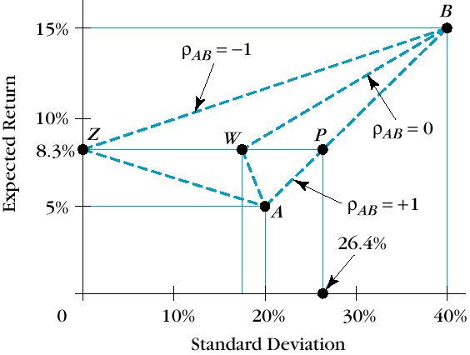
When we combine two stocks (A and B) to build a simplest portfolio as illustrated below, ρ plays an important role to determine the return and risk of portfolio. When c=1, it means two stocks have perfectly positive relation and will grow up and fall down in same proportion of price, while ρ= -1, they will still interact perfectly in same proportion of price, but in adverse directions. When ρ= 0, two stocks are totally independent. Look back to the following chart, Z, W, and P represent 3 possible portfolios with same weights of stock A and B. The only difference here is ρ. As we can see, given the same return, the smaller the ρ is, the less the risk investors take. At the extreme when ρ= -1, risk is completed hedged. Normally within same market in the real world, 1>ρ>0.

Now we consider all the possible portfolios which include certain numbers of stocks with all kinds of possible weights of stocks included, and then mark them on Return-Risk chart. We will finally find there’s an upper boundary (the blue curve shown in following chart). For every given level of feasible return, the minimal risk can be achieved at every point on the curve; while same for every given level of feasible risk, the highest feasible return can be found on the curve. This curve is called Efficient Frontier and the portfolios on it are called efficient portfolio.

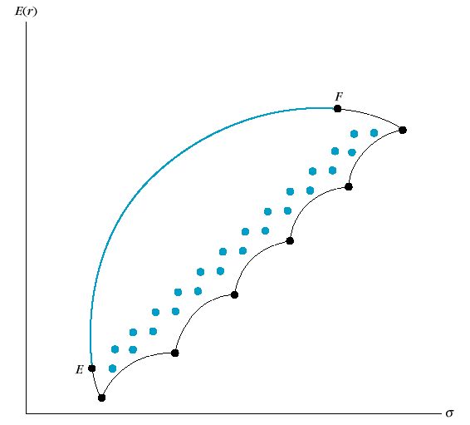

The above discussion is all about risky asset (stock). Now let’s think about a portfolio combining a risky asset and a risk-free asset. If we invest 100% of money into the risk-free asset, there should be no risk at all and we get return at RFR (Risk-Free Rate) as our portfolio return. Now we adjust the weight by putting part of risky asset into the portfolio, we will finally find a linear relationship between return and risk (as shown in following chart), which is logical, since the risky asset is the only contributor to the higher return along with higher the risk. This line is called AAL (Asset Allocation Line).

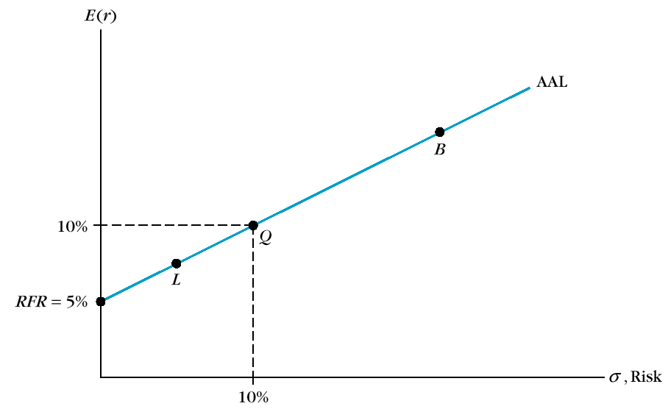

Now we can combine AAL and Efficient Frontier into one diagram, which represents investors’ normal investing strategy by reserving some of money for risk-free asset such as bank saving or treasury bill; or more aggressively, by borrowing risk-free money to invest into a risky asset (margin buy) with higher expectation of return. Look at the following chart, all the points here represent the portfolios of risky assets. When we want to adjust our investing strategy to be timid or aggressive by take the advantage of risk-free asset, we can just move the point along its AAL. Now pay attention to a special point M in the chart, which represents an efficient portfolio, while at the same time on its AAL, attains the highest slope, which means the highest feasible reward-to-variability ratio. We call this point Optimal Risky Portfolio and the AAL of that point is called Optimal CAL (Capital Allocation Line). This portfolio is an investor’s best combination of risky assets to be mixed with safe assets to form the complete portfolio.

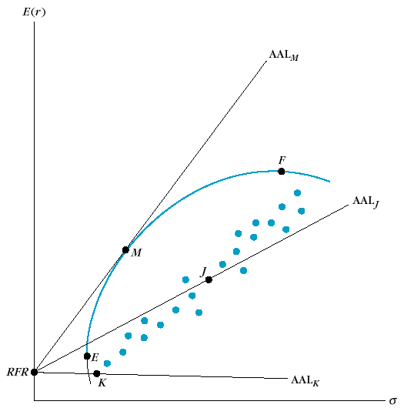
- Knowledge on Portfolio Optimization

In order to find the Optimal Risky Portfolio, we need several steps of calculation.

First, we are going to find the return and risk of the portfolio. Weighted return is easy to get, yet weighted variance (=standard deviation^2) is not that straightforward by applying the equation as followed.
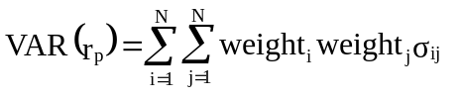
Here, σ_{ij} means the covariance between stock_{i} and stock_{j} within a portfolio. We can use powerful Excel built in statistical function COVAR to get covariance directly from historical data.

Actually the above equation can be expressed in a so-called Variance-Covariance Matrix. By using Excel function SUM, it’s very easy to get the sum of the matrix.

Row N
+x_{N}x_{NσNN}
….
+x_{N}x_{3σN3}
+x_{N}x_{2σN2}
+x_{N}x_{1σN1}
Row N-1
….
….
….
….
….
….

….
….
Col. N – 1
Row 3
+x₃x_{Nσ3N}
+x₃x_{3σ33}
+x₃x_{2σ32}
+x₃x_{1σ31}
Row 2
+x₂x_{Nσ2N}
+x₂x_{3σ21}
+x₂x_{2σ22}
+x₂x_{1σ21}
Row 1
+x₁x_{Nσ1N}
+x₁x_{3σ13}
+x₁x_{2σ12}
+x₁x_{1σ11}
Col. N
Col. 3
Col. 2
Col. 1

Second, AAL can be defined by:
Here, X_{Q} means the weight of risky asset while (1- X_{Q}) means the rest weight of risk-free asset. E(r_{p}) and E(r_{q}) mean the expected return of portfolio and risky asset respectively. (*What’s the difference between expected return and return? Return is the fact in the past, while expected return is the weighted average rate of possible return in future. When analyzing historical data, we replace expected return with return in the equation.) After transferring it a bit, we find the slope of AAL = 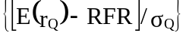

Now we can employ linear programming method through Excel Solver, to iterate all the possible weight combination within a given current portfolio to find the Optimal Risky Portfolio under the constraints:
  - The portfolio should be on Efficient Frontier.
  - The AAL of the portfolio should have the highest value in slope.
  - Effectiveness Test and Result
I’ve done an initial test in order to validate the model. I’ve selected 10 Canadian stocks and analyzed on their historical data during the past 5 years. Followed table is a summary of the key data, as well as the initial weights I choose based on common sense.

Company name | Ticker (.TO) | Std. Dev (%) | Average Ret. (%) | Weights
Bank of Montreal | BMO | 5.58% | 1.64% | 5.00%
Cascades Inc. | CAS | 6.60% | 0.79% | 15.00%
Canadian tire | CTR | 6.11% | 0.71% | 5.00%
Lowblow | L | 5.43% | 1.55% | 10.00%
Bell Canada | BCE | 5.86% | 0.00% | 5.00%
ATI TECH. | ATY | 19.84% | 2.42% | 5.00%
Shell Canada | SHC | 5.48% | 1.79% | 15.00%
Petro-Canada | PCA | 6.83% | 2.07% | 15.00%
QUEBECOR | IQW-SV | 9.44% | 0.41% | 10.00%
SOBEYS INC | SBY | 8.02% | 1.41% | 15.00%
 |  |  | Total | 100.00%

After performing optimization, I got the result.

 |  | Portfolio: | Original | Optimal Risky
Ticker | Std. Dev (%) | Average Ret. (%) | Weights | Weights
BMO | 5.58% | 1.64% | 5.00% | 25.87%
CAS | 6.60% | 0.79% | 15.00% | 10.88%
CTR | 6.11% | 0.71% | 5.00% | 3.98%
L | 5.43% | 1.55% | 10.00% | 16.42%
BCE | 5.86% | 0.00% | 5.00% | 0.00%
ATY | 19.84% | 2.42% | 5.00% | 8.21%
SHC | 5.48% | 1.79% | 15.00% | 11.57%
PCA | 6.83% | 2.07% | 15.00% | 22.82%
IQW-SV | 9.44% | 0.41% | 10.00% | 0.00%
SBY | 8.02% | 1.41% | 15.00% | 0.24%
Total |  |  | 100.00% | 100.00%
PORTFOLIO STATS
Mean: |  |  | 1.3432% | 1.6744%
Variance: |  |  | 0.1069% | 0.0877%
Std dev: |  |  | 3.2694% | 2.9612%

Look closely at the optimized weights. It suggests that the efficient portfolio needs only 8 stocks rather than previous planned 10 stocks. Clearly, Optimal Risky Portfolio will benefit investors much more than the original one, not even mentioning the savings on transaction fees or commissions.

If we show the result on a Return-Risk chart in a more straightforward way, it will be like:

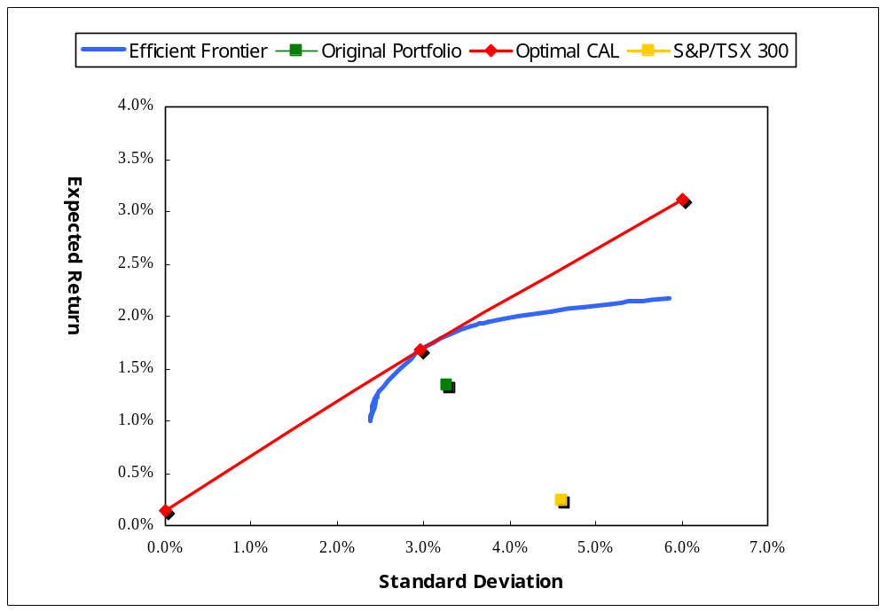

Remember this test is just to show some suggestions “after the fact”. To reveal the real value of the model in practice, we should test further on predictability as followed.
  - Predictability Test and Result
Predictability test is good to see if this model really works in the real financial world. First of the test is to calculate the optimized weights based only a previous year. Suppose we invest as this weights this year, record the real performance/return. Do the same optimization again from data of this year in order to predict the weights of next year that we will test the performance on. Loop like this way until the end.

Year | Original Portfolio | S&P/TSX 300 | Predicted Portfolio
2000 | 1.55% | 0.97%
2001 | 2.31% | -1.47% | 0.99%
2002 | 0.71% | -1.19% | 0.87%
2003 | 1.03% | 2.22% | 1.00%
2004 | 1.12% | 0.67% | 1.96%
Average Return | 1.29% | 0.06% | 1.21%
Std. Dev. | 0.62% | 1.55% | 0.50%
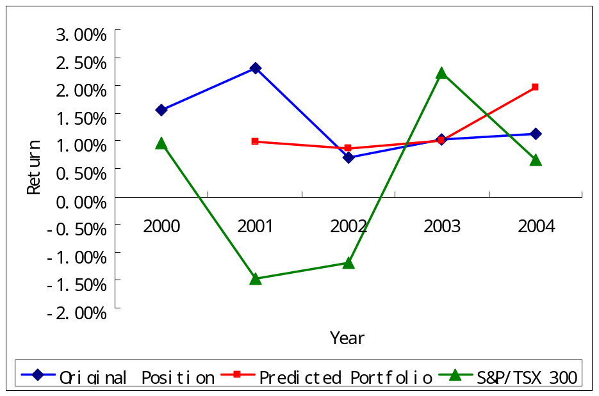

Here we find that although 4-year average performance of predicted portfolio is a bit lower than original portfolio, it provide more a stable return curve. We can argue that the model automatically reduce the high risk factors. Lastly, both of them outperform the market index.

  - Further Development: Transaction Fee Constraint
If we look at the details of the optimized weights based on each year (meanwhile the predicted weights for the next year), as showed in the above predictability test:

 | 2000 | 2001 | 2002 | 2003
BMO | 52.32% | 0.00% | 8.11% | 30.58%
CAS | 0.00% | 33.06% | 16.46% | 0.00%
CTR | 0.00% | 0.00% | 0.00% | 28.74%
L | 9.30% | 33.61% | 0.00% | 0.00%
BCE | 0.00% | 0.00% | 0.00% | 0.00%
ATY | 14.46% | 5.11% | 0.00% | 12.17%
SHC | 0.00% | 0.00% | 0.00% | 28.50%
PCA | 20.19% | 7.03% | 75.43% | 0.00%
IQW-SV | 3.73% | 0.00% | 0.00% | 0.00%
SBY | 0.00% | 21.19% | 0.00% | 0.00%

We can find that these predictions involve a lot of transaction especially the frequent buy and sell for a single stock, which leads to a lot of transaction fee or commissions. For sure those extra costs reduce the actual return. Therefore, we should consider this factor when modeling. (In fact, the above “weight patterns” also explain why our “stock survival model” fails, since there’s no stock will live or die forever. The market is highly dynamical. The best way may be to keep track on the market just-in-time.)
- *Stock Selection by Applying Genetic Programming (GP) Models
As we can see, the above Markowitz Portfolio Theory based model address the question of “How many to buy” within a given portfolio perfectly. Now, in order to address another question of “What to buy”, we introduce two GP based models.

- *Stock Survival Model
This stock selection model is aimed to select an effective group of stocks from a wide range of basis by filtering out unqualified stocks based on the past performance within the portfolio.

Look back to the previous optimized portfolios, we can find that some of the weights are equal to zero, which means investors completely don’t need to select them as a part of portfolio. In other word, these zero weight stocks can’t survive after optimizations. In terms of GP (Genetic Programming), the rule of survival is called fitness function. Here, the fitness function is like:

F(stock) = {if optimized weight > 0 : result = live; else result = die}
A question can easily come to mind is that: does a higher optimized weight mean a better stock? (Needs test…)

  - Predictability test
Like previous similar test, here we use stock survival model to learn the past one year then predict the performance in the next year. This result is more meaningful in practice.

Year | Original Portfolio | S&P/TSX 300 | Stock Survival Model | Stocks left
2000 | 1.55% | 0.97% |  | 5
2001 | 2.31% | -1.47% | 0.99% | 3
2002 | 0.71% | -1.19% | -1.62% | 2
2003 | 1.03% | 2.22% | 1.32% | 1
2004 | 1.12% | 0.67% | 1.16% | 1
Average Return | 1.29% | 0.06% | 0.46%

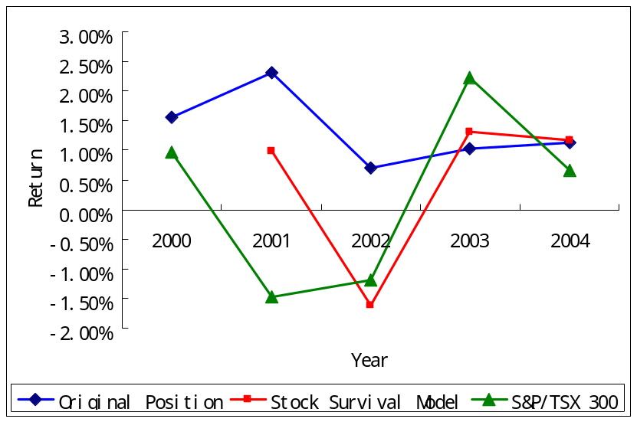
The result over 4 years is not that good. Part of the reason is that fitness function eliminates too many stocks too early so that portfolio can’t balance finally. That’s why we need some adjustment to control the minimal size of the portfolio as discussed before.

Let’s modify the survival rule a bit: let the model learn one more year, and then decide those stocks whose weights are zero twice continuously over two years should be filtered out

Year | Original Portfolio | S&P/TSX 300 | Stock Survival Model | Stocks left
2000 | 1.55% | 0.97% |  | 10
2001 | 2.31% | -1.47% |  | 10
2002 | 0.71% | -1.19% | 0.87% | 7
2003 | 1.03% | 2.22% | 1.00% | 6
2004 | 1.12% | 0.67% | 0.44% | 5
Average Return | 0.95% | 0.57% | 0.77%

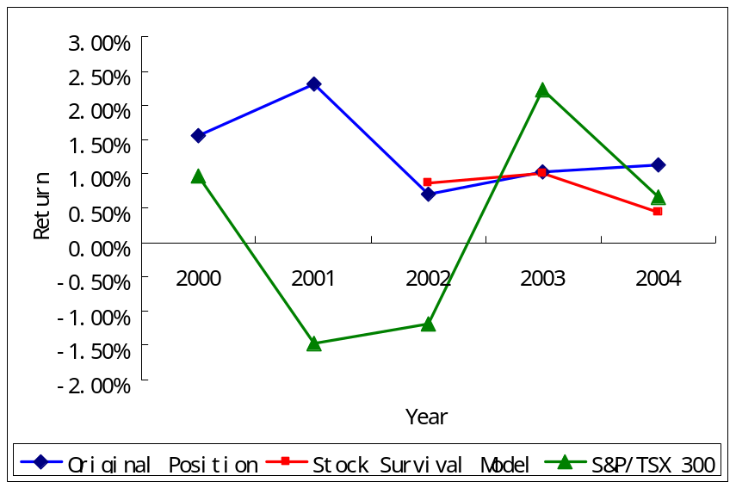
Clearly, this 3-year result is better than our previous result and still better than market index performance, yet lower than original portfolio built from common sense.

All in all, to choose a proper fitness function is the key difficulty for this model.

However, the simple rule we used above in fact may be too restrictive to let most stocks survive (See the followed tests). A more complex yet meaningful fitness function can be developed based on financial theory as followed.

Empirical test (Chen, Roll and Ross 1986) on APT (Arbitrage Pricing Theory) isolated 4 factors that significantly influenced securities return:
- Changes in the rate of inflation (f₁)
- Changes in the index of industrial production (f₂)
- Changes in the yield spread between high-grade and low-grade corporate bonds, a measure of investor confidence (f₃)
- Changes in the slope of the term structure of interest rates, as measured by the difference in between the yield on long-term government bonds and T-bills (f₄)
If we introduce these variables into the fitness function, it could be more precise to describe the rule of filtering:

F(stock) = {α₁* f₁ + α₂* f₂ + α₃*f₃ + α₄*f₄ >β : result = live; else result = die}
How to determine these coefficients α_{n} as well as the survival levelβ? We plan to use GP (Genetic Programming) again to let model itself learn from historical data and then choose the best fitness function according to best return/risk ratio which could be achieved.

Due to the transaction fees in the real world trading, we believe there’s a balance point on the number of stocks chosen to build a portfolio. If we choose too many stocks, extra transaction fees will be high, meanwhile, if we choose too few, the risk of the portfolio will be hard to balance and control. (Further adjustment to the model needs to be done to address impact from transaction fees in order to determine the proper size of portfolio)

- *Portfolios Evolution Model
Inspired by the concepts of biological evolution (selection, crossover, and mutation), we can develop a different yet more traditional model to build an efficient portfolio. The difference between this model and the above one is the different view on competing unit. In stock survival model, every single stock competes with each other in order to survive in the portfolio, while in portfolios evolution model, every portfolio competes with each other. The difference also leads to different algorithm.

Steps of algorithm:
- Initialization: Randomly select a number of stocks to build several portfolios. The number of portfolios can be divided by 3. (The size of portfolio can be further determined by above discussed transaction fee adjustment)
- Selection: Let them compete on the historical data. Watch their optimized performance periodically. 1/3 of portfolios with the worst performance will “die”. We can also express this rule as a fitness function:
F(portfolio) = {if optimized performance is in top 2/3 of all the portfolios : result = live; else result = die}
- Crossover: For the rest of 2/3 of portfolios, randomly make pair of them. For each pair, randomly select stocks from both portfolios to form a next “child” portfolio. Here, we discard the original weights, since we can always calculate the optimized weight for the new portfolio.
- Mutation: Also when generating child portfolio, there’s a probability to introduce a complete new stock, which means that new stock is not within two parent portfolios, into the new portfolio. (To determine this probability…another long story)
- Loop: Move back to step 2 and keep the evolution until some relative stable portfolio structures come out.

As we can see, this model is dynamic and maybe evolves forever. The top 1 may not be that stable, but we can score on the historical ranks during a period in order to identify those high performance portfolios in general.

This model may be better on the first since the fitness rule is more straight forward and also simple to implement. However, this model can’t give out a final result, since the model is always dynamically evolving so as to keep tracking the real market. Also this model requires much more computational power to support.

  - Predictability test
The initial test prototype shows the following result:

Year | Original Portfolio | S&P/TSX 300 | Stable Portfolio
2000 | 1.55% | 0.97%
2001 | 2.31% | -1.47% | -0.41%
2002 | 0.71% | -1.19% | 0.21%
2003 | 1.03% | 2.22% | 1.00%
2004 | 1.12% | 0.67% | 0.21%
Average | 1.29% | 0.06% | 0.25%
Std. Dev. | 0.70% | 1.73% | 0.58%

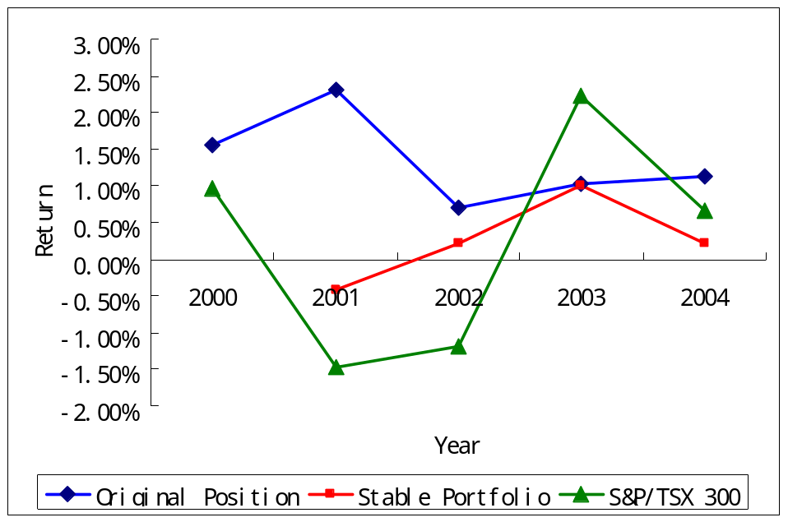

  - Conclusion on GP
To summarize why the above two GP based model is not satisfying, we can attribute to 3 reasons:
1) The sample is too small
2) The prediction period is too long
3) More fundamentally, the detailed weight pattern we find above in normal portfolio optimization prediction shows that the market is very dynamical and the model should be adaptive enough; however during evolution, the elimination of stocks reduces the flexibility of the whole tested portfolio.

New Horizon

*Historical data should have only limited impact. The killed stock from portfolio seed should have some chance to come back or just keep sleeping.
*Transaction fee should be considered in weights changing
*Price-Volume Pattern consideration: psychological finance
*All the above prediction tests assume that there’s only one transaction/year, which happens at the end of the previous year as well as the beginning the next year. That’s unrealistic.
*A number of independent portfolio agents are introduced the virtual competition. Independence means there’s no cooperation/communication between each other.
*The scope of time series should also be considered. Some agents are long term investors, while others are short term like.
*MPT shows what the best solution is for the past. The result itself by nature lacks the power of predictability. In order to predict the certain price behavior, pattern recognition is a good way to ahead. Moreover, each agent can have its own knowledge base for previous learned patterns.
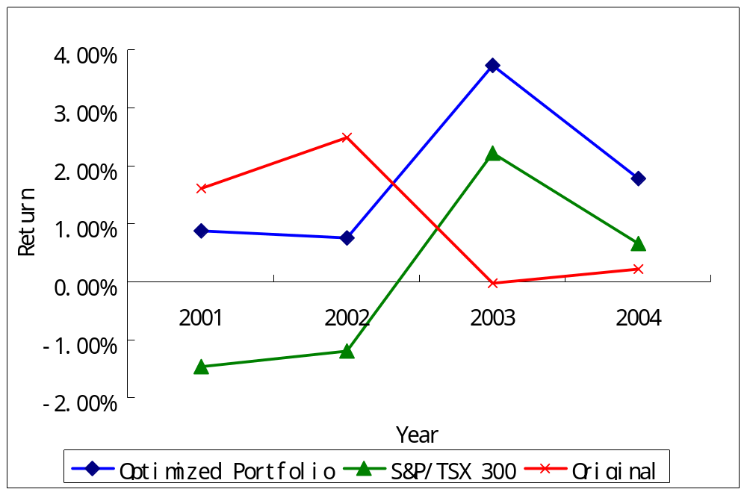
Interface
(*Interface Guide)

- Output

(*Report Guide)

System Limitation

Actually there’s a third investing decision to make in addition to those two I’ve listed at the beginning: when to sell. It’s hard to predict future prices in the long run based on EMH (Efficient Market Hypothesis), which states the prices in any efficient market should random-walk, since new information is unpredictable and the current prices have already reflected all the available information. However, emerging technology such as genetic programming may shed a light on short-term simulation so as to data-mine some underlying information quicker than others.

- Future Plan

  - More interactive user interface
  - Dynamic data loading from Yahoo Finance at background

- Conclusion
Appendix: Reference and Resource

I’ve find some useful papers from library as well as ProQuest database. I may or may not refer those papers until I take time to read them thoroughly. Some of them will be helpful for my future plan.

J. C. Fancis and R. Ibbotson: “Investments: A Global Perspective,” 2002, Ch. 14.

Sengupta, Chandan: “Financial modeling: using Excel and VBA,” 2004. Ch.

C. Gustav Lundberg and A. C. Barna: “Modeling Commodity Trading Expertise,” 1992

R. J. Bauer, Jr. and G. E. Liepins: “Genetic Algorithms and Computerized Trading Strategies,” 1992

Wong, F. S.; Wang, P. Z.; Goh, T. H.; Quek, B. K. “Fuzzy Neural Systems for Stock Selection
,” Financial Analysts Journal; Jan/Feb 1992; pg. 47

Richard J Bauer Jr; F Gregory Fitz-Gerald: “Using genetic programming to design a generalized trading system,” Managerial Finance; 2000; pg. 1

Thomas S. Y. Ho and Sang B. L.: “The Oxford Guide to Financial Modeling,” 2004, Ch. 2

J. G. L. Lazo, M. A. C. Pacheco, M. M. R. Vellasco: “Portfolio Selection and Management using a Hydrid Intelligent and Statistical System,” GA and GP in Computational Finance, pg 221-238, 2002

Draft area:

The Investors of Tomorrow competition system utilizes commissions. The minimum commission on any transaction is $25. Expanding on this, purchases of more than 1000 shares work using the following principle. On stocks which cost over $2.00 per share, the commission is 3 cents per share. On stocks which cost less, the commission is worth 1.5% of the total transaction value. Commissions occur on all buy/sell transactions. Patience

